Topics listed below may be repeated-

Garbage collector

Garbage implementations

Array List

Linked List

Iterator

List Iterator

TreeSet

Thread Safety

Comparator Interface

Implement the compareTo() method

iNHERITANCE:

Super class variables can be accessed inside subclass

Remaining Design Patterns

Data Structure Implementations

Look at Complete Reference - See which concepts you don’t know in index -Do them

Design Pattern Implementations

**Implementations**

Stack using array

Stack using linked list

Stack using queue

Queue using stack

Queue using linked list

Set using Hashmap

Set using linked list

Linked List

Stack

Queue

Set

Map

HashSet

HashMap

Array list

Linked list

Garbage collector()

Algorithms of Garbage collector

JMS

Interface-

When a class implementing the interface wants to call its the interface’s default method, then, it should use **InterfaceName.super.method()**

ELLIPSIS: VARARGS

Boxing

Unboxing

Casting primitive data types int double long float

Comparator

Comparable

Comparable:

Implementation for all data structures and concepts

PILLARS of OOPS

Collections

Implementations of each collection

Data Structures:

Arrays, Lists

Strings

Linkedlists

Stacks

Queues

Package vs assembly

***Dependency injection: https://www.journaldev.com/2394/java-dependency-injection-design-pattern-example-tutorial

Memory management of stack and heap

Functional Programming

Understand basics,

Learn simple implementations of concepts using FP in Java

Design Pattern (Java and Android with implementations- Understand where to employ these patterns)

Design Patterns

Strategy

Dependency injection

Restful services

Stack using queue

Queue using stack

Stack using linked list

Queue using linked list

Access specifiers:

<https://docs.oracle.com/javase/tutorial/java/javaOO/accesscontrol.html>

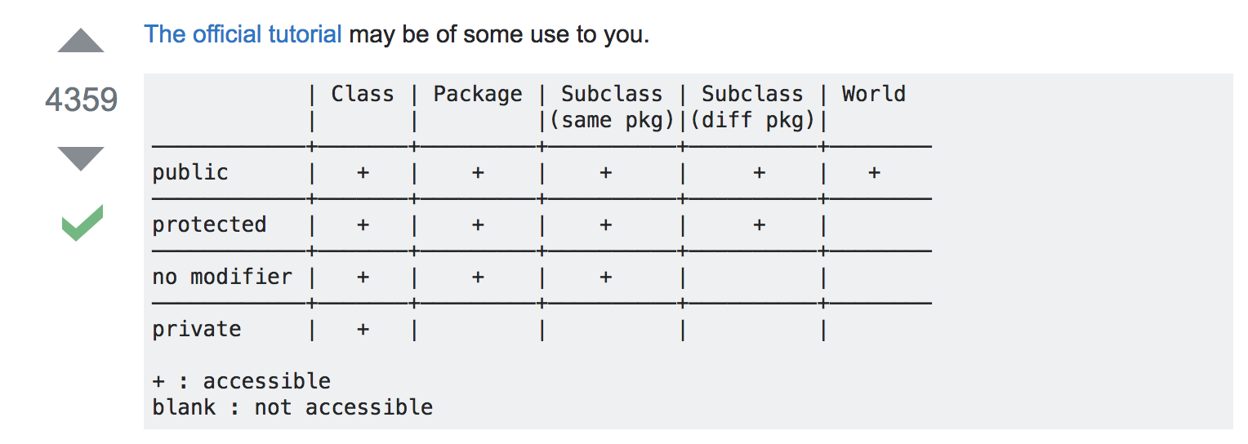

**The private (most restrictive) fields or methods cannot be used for classes and Interfaces**.

**It also cannot be used for fields and methods within an interface**.

Fields, methods or constructors declared private are strictly controlled, which means they cannot be accessed by anywhere outside the enclosing class. A standard design strategy is to make all fields private and provide public getter methods for them.

**Java is platform independent:** <https://www.geeksforgeeks.org/java-platform-independent/>

What is a compiler:

it is a program that converts

(Human understandable) **Source code**  **—>** **COMPILER —> Executable Code** (Machine understandable)

C / C++ Compiler : (Platform dependent) gives executable code - it is a sequence of machine instructions that can be executed by the CPU directly,

Java Compiler: (Platform independent) gives byte code - intermediate representation in Java is the **Java Byte Code.**

Java Byte code

JVM

JRE

JIT

Dynamic translation / run time compilation

Floating point numbers:

<https://www.youtube.com/watch?v=PZRI1IfStY0>

How to represent a number in IEEE Floating point notation

<https://www.youtube.com/watch?v=8afbTaA-gOQ>

Stack vs Heap: ***** Good watch

<https://www.youtube.com/watch?v=UcPuWY0wn3w>

String memory allocation in Java:

<https://www.youtube.com/watch?v=to9DPVsdByE>

Why string is immutable:

<https://www.youtube.com/watch?v=ZMfMMbEzKE4>

What is string pooling?

<https://www.youtube.com/watch?v=47-kDKPWBBM&feature=youtu.be>

GARBAGE COLLECTOR:

*In languages like* ***Java****,****dangling pointers cannot occur****because there is no mechanism to explicitly deallocate memory. Rather, the garbage collector may deallocate memory, but only when the object is no longer reachable from any references.*

**Difference between abstract class and concrete class:**

<https://sayemdb.wordpress.com/2011/05/17/an-intro-to-design-pattern-2/>

The only real difference is that a concrete class can be instantiated because it provides (or inherits) the implementation for all of its methods. An abstract class cannot be instantiated because at least one method has not been implemented.

Why Multiple Inheritance is Not Supported in Java

[**https://javapapers.com/core-java/why-multiple-inheritance-is-not-supported-in-java/**](https://javapapers.com/core-java/why-multiple-inheritance-is-not-supported-in-java/)

**Diamond problem**

**Null can be cast to any reference type;**

**Any type can’t be cast to null;**

CS 474 Names, Scopes and Bindings

<https://en.wikibooks.org/wiki/Introduction_to_Programming_Languages/Binding>

The binding between the parameter name and the variable that was passed, has a lifetime shorter than that of the variable itself.

**Parameter-variable binding shorter than variable lifetime**

It is also possible, though generally a sign of a program bug, **for a name-to-object binding to have a lifetime longer than that of the object.** In C++ it is called a dangling pointer

**Dangling Pointers**

Dangling pointers arise when an object is deleted or deallocated, without modifying the value of the pointer, so that the pointer still points to the memory location of the deallocated memory, which may now be used by another object.

*In languages like* ***Java****,****dangling pointers cannot occur****because there is no mechanism to explicitly deallocate memory. Rather, the garbage collector may deallocate memory, but only when the object is no longer reachable from any references.*

**Static, Stack and Heap allocation**

<https://stackoverflow.com/questions/408670/stack-static-and-heap-in-c>

**How does late binding allow polymorphism?**

**What is Duck Typing?**

<https://ericlippert.com/2014/01/02/what-is-duck-typing/>

**QUIZ**

[**https://quizlet.com/125304196/31-32-flash-cards/**](https://quizlet.com/125304196/31-32-flash-cards/)

**STATIC TYPING VS DYNAMIC TYPING**

<https://pythonconquerstheuniverse.wordpress.com/2009/10/03/static-vs-dynamic-typing-of-programming-languages/>

<http://nightmare.mit.edu/>

**REGEX CHEAT SHEET:**

<http://files.zeroturnaround.com/pdf/zt_regular-expressions-cheat-sheet.pdf>

https://www.youtube.com/watch?v=sa-TUpSx1JA

LEARN

<https://www.geeksforgeeks.org/quantifiers-in-java/>

<https://www.tutorialspoint.com/java/java_regular_expressions.htm>

**STRING MANIPULATION:**

https://docs.oracle.com/javase/tutorial/java/data/manipstrings.html

Substring() method

https://www.youtube.com/watch?v=US4v4SD0iiU

Replace() vs replaceAll()

ReplaceAll()

https://www.javatpoint.com/java-string-replaceall

**ASCII vs Unicode (UTF)**

ASCII defines 128 characters, which map to the numbers 0–127. Unicode defines (less than) 221characters, which, similarly, map to numbers 0–221 (though not all numbers are currently assigned, and some are reserved).

Unicode is a superset of ASCII, and the numbers 0–128 have the same meaning in ASCII as they have in Unicode. For example, the number 65 means "Latin capital 'A'".

Because Unicode characters don't generally fit into one 8-bit byte, there are numerous ways of storing Unicode characters in byte sequences, such as UTF-32 and UTF-8.

<http://cs-fundamentals.com/java-programming/java-primitive-data-types.php>

Floating-point literals in Java default to double precision. To specify a float literal, you must append an F or f to the constant. You can also explicitly specify a double literal by appending a D or d. Doing so is, of course, redundant. The default double type consumes 64 bits of storage, while the less-accurate float type requires only 32 bits

As mentioned earlier, Java also performs an automatic type conversion when storing a l**iteral integer** constant into variables of type byte, short, long, or char.

For example:

x = 42;

y = ++x;

In this case, y is set to 43 as you would expect, because the increment occurs before x is assigned to y. Thus, the line y = ++x; is the equivalent of these two statements:

x = x + 1;

y = x;

However, when written like this,

x = 42;

y = x++;

the value of x is obtained before the increment operator is executed, so the value of y is 42. Of course, in both cases x is set to 43. Here, the line y = x++; is the equivalent of these two statements:

y = x;

x = x + 1;

Automatic Type Promotion in Expressions In addition to assignments, there is another place where certain type conversions may occur: in expressions. To see why, consider the following. In an expression, the precision required of an intermediate value will sometimes exceed the range of either operand. For example, examine the following expression: byte a = 40; byte b = 50; byte c = 100; int d = a * b / c; The result of the intermediate term a*b easily exceeds the range of either of its byte operands. To handle this kind of problem, Java automatically promotes each byte, short, or char operand to int when evaluating an expression. This means that the subexpression a*b is performed using integers—not bytes. Thus, 2,000, the result of the intermediate expression, 50 * 40, is legal even though a and b are both specified as type byte. As useful as the automatic promotions are, they can cause confusing compile-time errors. For example, this seemingly correct code causes a problem: byte b = 50; b = b * 2; // Error! Cannot assign an int to a byte! The code is attempting to store 50 * 2, a perfectly valid byte value, back into a byte variable. However, because the operands were automatically promoted to int when the expression was evaluated, the result has also been promoted to int. Thus, the result of the expression is now of type int, which cannot be assigned to a byte without the use of a cast. This is true even if, as in this particular case, the value being assigned would still fit in the target type. In cases where you understand the consequences of overflow, you should use an explicit cast, such as byte b = 50; b = (byte)(b * 2); which yields the correct value of 100

When used inside a set of nested loops, the break statement will only break out of the innermost loop. For example:

[String, StringBuffer, and StringBuilder](https://stackoverflow.com/questions/2971315/string-stringbuffer-and-stringbuilder)

**Mutability Difference:**

String is **immutable**, if you try to alter their values, another object gets created, whereas StringBuffer and StringBuilder are **mutable** so they can change their values.

**Thread-Safety Difference:**

The difference between StringBuffer and StringBuilder is that StringBuffer is thread-safe. So when the application needs to be run only in a single thread then it is better to use StringBuilder. StringBuilder is more efficient than StringBuffer.

**Situations:**

* If your string is not going to change use a String class because a String object is immutable.
* If your string can change (example: lots of logic and operations in the construction of the string) and will only be accessed from a single thread, using a StringBuilder is good enough.
* If your string can change, and will be accessed from multiple threads, use a StringBufferbecause StringBuffer is synchronous so you have thread-safety.

*Walk me through your CV? Strengths / Weaknesses? Which car would you buy?*

*What is the most exciting project you&#039;ve worked on in  the past two years?*

String manupulation

<https://docs.oracle.com/javase/tutorial/java/data/manipstrings.html>

**String implements the CharSequence interface.**

**So, any method expecting a CharSequence also accepts a string**

Example: contains(), replace()

|  |  |
| --- | --- |
| String replace(char oldChar, char newChar) | Returns a new string resulting from replacing all occurrences of oldChar in this string with newChar. |
| String replace(CharSequence target, CharSequence replacement) | Replaces each substring of this string that matches the literal target sequence with the specified literal replacement sequence. |

Regular Expressions:

<http://files.zeroturnaround.com/pdf/zt_regular-expressions-cheat-sheet.pdf>

Searching and sorting

building a system for mobile game app

**Why can't I declare a static variable inside main() method in Java?**

You cannot declare a static variable within ANY method. Static variables have to be declared at a class level

(You might have read that static variables are shared by all objects of that class - same value is accessed by all objects, change in value by one object is also experienced by all objects)

<https://www.quora.com/Why-cant-I-declare-a-static-variable-inside-main-method-in-Java>

I would like to share with you the difference between STATIC FIELDS and FINAL VARIABLES (You can declare a FINAL VARIABLE inside a method But you CANNOT declare STATIC FIELD inside a method).

**Is a variable initialization necessary in Java?**

**(GLOBAL)**

**STATIC VARIABLE,**

**INSTANCE VARIABLE**

**BOOLEAN VARIABLE LOCAL VARIABLE**

NO YES

NO If your variable is **global (static variable, instance or boolean type** then it is not necessary to initialize them , because default value for class variable is 0 , and for boolean it is false… (null, 0 , false)

YES you need to intialize variable if you are declaring **local variable** inside any functions or in constructors…

because in case of c or c++ if we dont intialize variable and make use of that variable or simply if we print that variable then it will print garbage value…but java contains garbage collector which will not allows variables to give garbage values so it gives error to user for that variable must be initialized…

Non Static global field can’t be referenced from a static context.

**READING CONTINUOUS INPUT:**

BufferedReader **br** = new BufferedReader( new InputStreamReader( System.in ) );

String first = br.readLine();

String second = br.readLine();

[Why doesn’t == work on String? [duplicate]](https://stackoverflow.com/questions/17443201/why-doesn-t-work-on-string).

READ FULL POST!!!!! Click on the link.

**Thread safe vs Non-thread safe- Check**

**https://www.quora.com/What-are-the-Thread-safe-classes-in-Java-Collections-framework**

DIFFERENCE BETWEEN ARRAY AND ARRAYLIST

<http://javahungry.blogspot.com/2015/03/difference-between-array-and-arraylist-in-java-example.html>

<https://www.iro.umontreal.ca/~pift1025/bigjava/Ch08/ch08.html>

https://www.tutorialspoint.com/java/util/java_util_arraylist.htm

Arrays are static in nature. Arrays are fixed length data structures. You can’t change their size once they are created. ArrayList is dynamic in nature. Its size is automatically increased if you add elements beyond its capacity.

Arrays can hold both primitives as well as objects. ArrayList can hold only objects.

Arrays can be iterated only through for loop or for-each loop. ArrayList provides iterators to iterate through their elements.

The size of an array is checked using length attribute.The size of an ArrayList can be checked using size() method.

Array gives constant time performance for both add and get operations. ArrayListalso gives constant time performance for both add and get operations provided adding an element doesn’t trigger resize.

Arrays don’t support generics. ArrayList supports generics.

Arrays are not type safe. ArrayList are type safe.

Arrays can be multi-dimensional. ArrayList can’t be multi-dimensional.

Elements are added using assignment operator. Elements are added using add() method.

Methods in ArrayList : might be helpful known



Following picture represents array myList. Here, myList holds ten double values and the indices are from 0 to 9.





WHY DO WE USE List list = new ArrayList();

INSTEAD OF Arraylist list = new ArrayList();

https://stackoverflow.com/questions/23991119/what-is-difference-between-liststring-list-new-arrayliststring-and-array

When someone writes code like this, he/she is trying to follow a basic OO design principle which says -

Program to an interface, not to a concrete implementation

I have explained this principle in [one of my blog posts](http://sayemdb.wordpress.com/2011/05/17/an-intro-to-design-pattern-2/). Look in the Class Inheritance VS Interface Inheritance section.

**CAN WE INSTANTIATE AN INTERFACE?**

**https://www.tuturself.com/posts/view?menuId=54&postId=1045**

Also remember while implementing an interface by anonymous inner class, you cannot implement more than one interface. In fact, an anonymous inner class can't even extend a class and implement an interface at the same time.

*You can't instantiate an interface, yet that's what the code looks like it's doing. But, of course,*

*it's not instantiating an Animal object-- it's creating an instance of a new anonymous implementer of Animal.*

*The above code is same like creating a class which is implementing the Animal interface.*

*The only difference here is the created class is an anonymous inner class.*

*Also remember while implementing an interface by anonymous inner class, you cannot implement more than one interface.*

*In fact, an anonymous inner class can't even extend a class and implement an interface at the same time.*

*So don’t be fool in an interview in this question. Interface cannot be instantiated,*

*the following is an invalid statement.*

*Runnable r = new Runnable(); // can't instantiate interface*

*whereas the following is legal, because it's INSTANTIATING AN IMPLEMENTER CLASS OF THE RUNNABLE INTERFACE*

*(an anonymous implementation class):*

*Runnable r = new Runnable() {*

*public void run(){ }*

*};*

**ANONYMOUS INNER CLASSES:**

By an "anonymous class", I take it you mean [anonymous inner class](http://docs.oracle.com/javase/tutorial/java/javaOO/innerclasses.html).

An anonymous inner class can come useful when making an instance of an object with certain "extras" such as overloading methods, without having to actually subclass a class.

I tend to use it as a shortcut for attaching an event listener:

button.addActionListener(new ActionListener() {

@Override

public void actionPerformed(ActionEvent e) {

// do something

}

});

Using this method makes coding a little bit quicker, as I don't need to make an extra class that implements ActionListener -- I can just instantiate an anonymous inner class without actually making a separate class.

I only use this technique for "quick and dirty" tasks where making an entire class feels unnecessary. Having multiple anonymous inner classes that do exactly the same thing should be refactored to an actual class, be it an inner class or a separate class.

**AUTOBOXING AND UNBOXING:** [**https://docs.oracle.com/javase/tutorial/java/data/autoboxing.html**](https://docs.oracle.com/javase/tutorial/java/data/autoboxing.html)

As you are aware, In Java not everything is an Object. There are primitive types such as int ,double float etc. So if you wanted to use a primitive type in place of Object i.e. if a method expects an Object but you need to send in a primitive type, without Wrapper classes this wouldn't be possible. Take for instance the Map interface. The put(Object,Object) method takes Objects as both key and value. If you, for example wanted to store a mapping between an integer value 1 (int i=1) to an Object, without wrapper classes this wouldn't be possible. Wrapper classes are used to represent primitive values when an object is required.

Consider the following code:

List<Integer> list = new ArrayList<>();

for (int i = 1; i < 50; i += 2)

list.add(i);

Although you add the int values as primitive types, rather than Integer objects, to list, the code compiles. Because li is a list of Integer objects, not a list of int values, you may wonder why the Java compiler does not issue a compile-time error. The compiler does not generate an error because it creates an Integer object from i and adds the object to list. Thus, the compiler converts the previous code to the following at runtime:

List<Integer> li = new ArrayList<>();

for (int i = 1; i < 50; i += 2)

li.add(Integer.valueOf(i));

Converting a primitive value (an int, for example) into an object of the corresponding wrapper class (Integer) is called autoboxing. The Java compiler applies autoboxing when a primitive value is:

* Passed as a parameter to a method that expects an object of the corresponding wrapper class.
* Assigned to a variable of the corresponding wrapper class.

public static int sumEven(List<Integer> li) {

int sum = 0;

for (Integer i: li)

if (i % 2 == 0)

sum += i;

return sum;

}

Because the remainder (%) and unary plus (+=) operators do not apply to Integer objects, you may wonder why the Java compiler compiles the method without issuing any errors. The compiler does not generate an error because it invokes the intValue method to convert an Integer to an int at runtime:

public static int sumEven(List<Integer> list) {

int sum = 0;

for (Integer i : li)

if (i.intValue() % 2 == 0)

sum += i.intValue();

return sum;

}

Converting an object of a wrapper type (Integer) to its corresponding primitive (int) value is called unboxing. The Java compiler applies unboxing when an object of a wrapper class is:

* Passed as a parameter to a method that expects a value of the corresponding primitive type.
* Assigned to a variable of the corresponding primitive type.

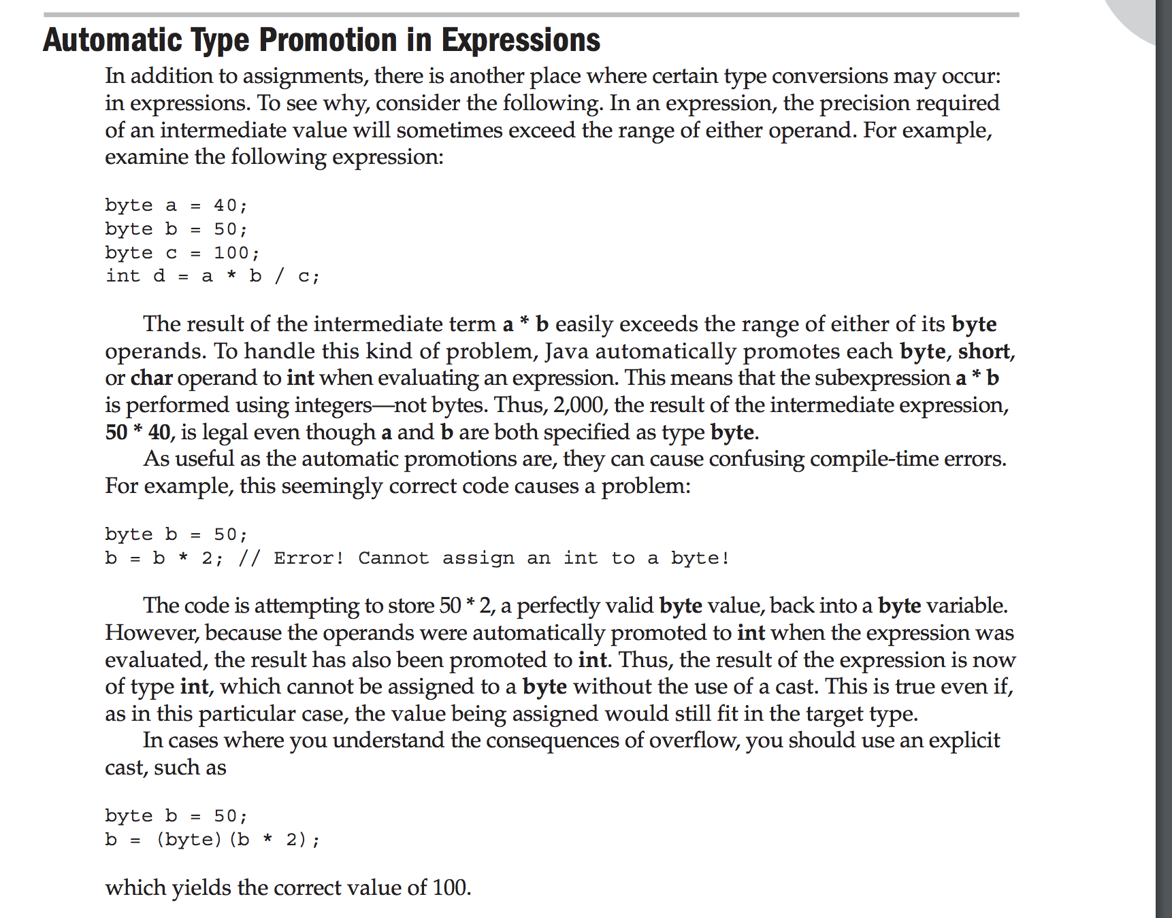

**ELLIPSIS: VARARGS ( Variable no of arguments)**

**Represented using “…”**

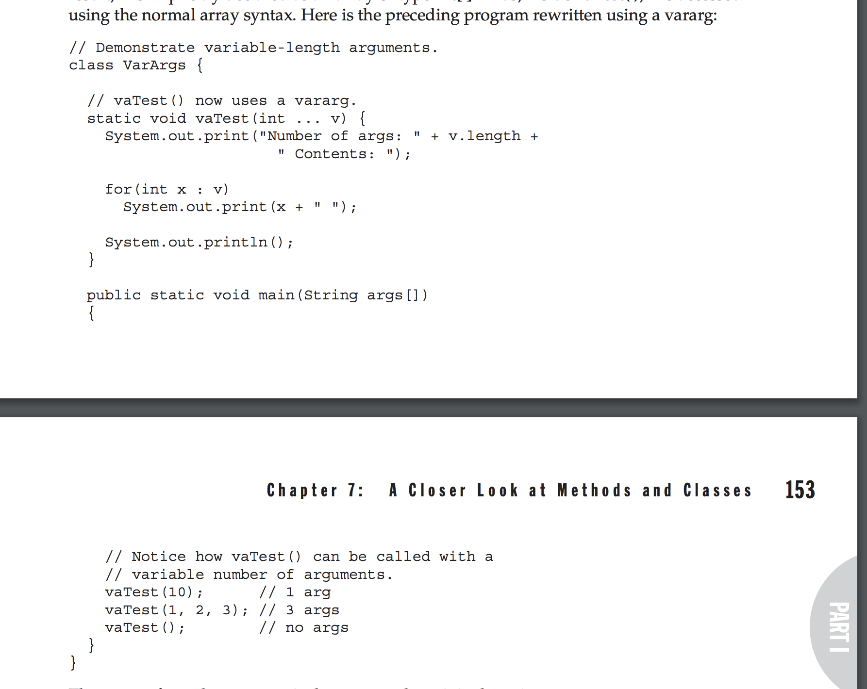



**JAVA COLLECTIONS CHEAT SHEET!!**

[**http://files.zeroturnaround.com/pdf/zt_java_collections_cheat_sheet.pdf**](http://files.zeroturnaround.com/pdf/zt_java_collections_cheat_sheet.pdf)

**HASHMAP:**

**HashMap put() method**

**HashMap default size = 16**

**Every Bucket is a node in a linked list storing**

**Key | Value | HashCode | Next**

**Default size (size of buckets created) is 16**

**Elements with same hashcode are inserted into the same bucket**

**How HashMap works internally || Popular java interview question on collection (HashMap)**

How HashMap works internally || Popular java interview question on collection (HashMap)

[**https://www.youtube.com/watch?v=CojCE-ojdGY**](https://www.youtube.com/watch?v=CojCE-ojdGY)

PRACTICAL]How Hashmap works internally || Debugging || part 2

[**https://www.youtube.com/watch?v=fSjxhOYPBRI**](https://www.youtube.com/watch?v=fSjxhOYPBRI)

**Map features: (can be specified at the time of construction)**

**Initial Capacity = 16**

Default initial size of Map is 16

Initial map creation will create 16 buckets from 0 to 15 indexes.. each representing a node of a linked list.

**Load factor = 0.75 (default)**

It means that when map is 75% full, the map size will be doubled.

75% (16) = 12. (**Threshold = 12)**

So, when 12 buckets of your initial capacity contain data, then, map size will be doubled.

**When a map.put(“aaa”,1) is done, first, the**

Step 1: Compute **hashCode(“aaa”)**

Step 2: Find the index of bucket using modulo operation

Step 3: At that index, following will be added.

**key=“aaa” | hashCode(“aaa”) | Value = 1 | next = null**

**Before threshold is reached** 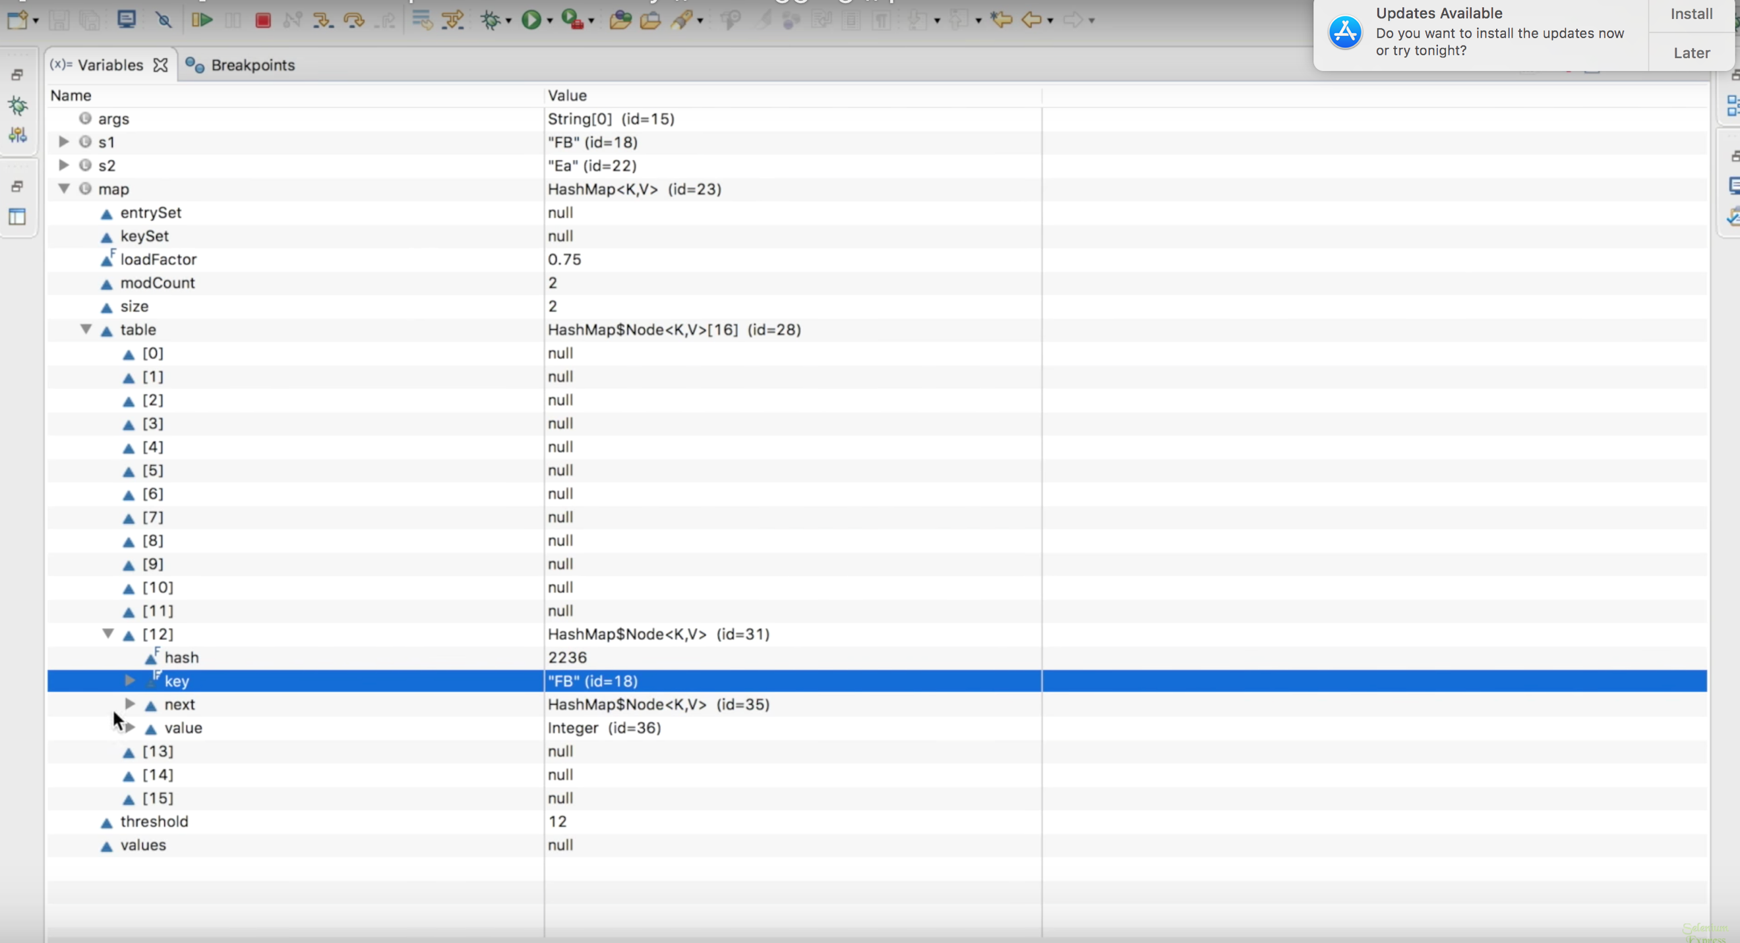

**Load factor is a value (default is 0.75)**

0.75* (16) = 12. (**Threshold = 12). It means that when the map is 75% filled, the map size will just double.**

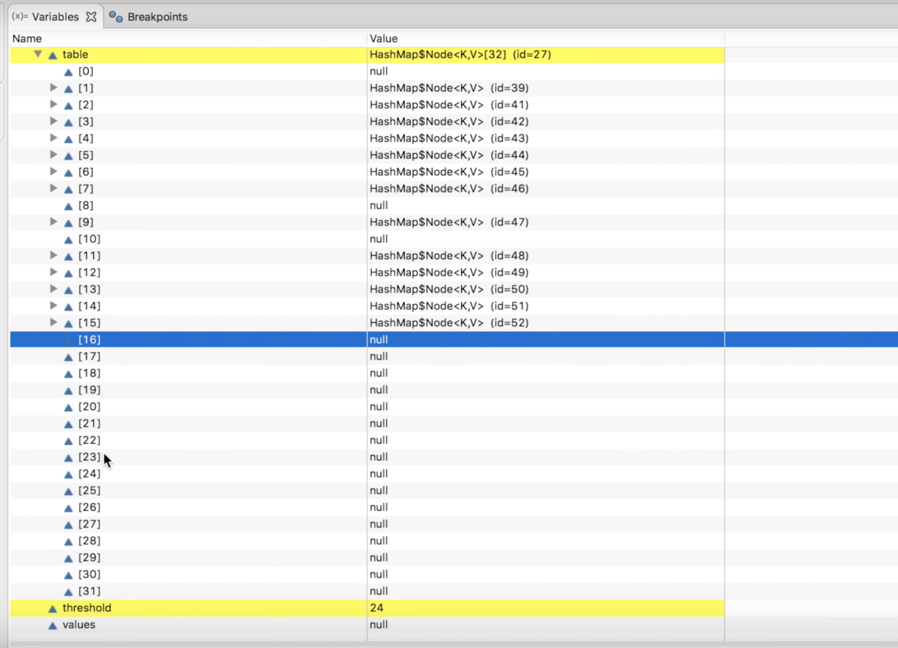

**How the get(Key k) method works within a HashMap|| Part 3**

<https://www.youtube.com/watch?v=AVSGJHrrLpE>

**Equals and Hashcode contract**

[**https://www.youtube.com/watch?v=IwUwIrz9Ge8**](https://www.youtube.com/watch?v=IwUwIrz9Ge8)

**For all set based collections**

When you dont provide hashcode implementation, Hash based collections(map,set) uses system generated hashcode to store and retrieve, which happens to be different even when two objects have the same attributes.

The method put has a return type same with the value:

@Override

public V put(K key, V value) {

return putImpl(key, value);

}

The method associates the specified value with the specified key in this map. If the map previously contained a mapping for the key, the old value is replaced. It returns the previous value associated with key, or null if there was no mapping for key.So, your points are right. For more details please visit [here](http://docs.oracle.com/javase/6/docs/api/java/util/HashMap.html)

private Map<Bookmark, Integer> mDevice = new HashMap<String, Integer>();

String abc = "two"

Integer ret = mDevice.put(abc, ONLINE);

* if abc key already exists with value "OFFLINE", ret is equal to OFFLINE
* if abc key already exists with value "ONLINE", ret is equal to ONLINE
* if abc key did not exist, then ret is equal to null.

SET

SET- Unique Elements

HashSet- Unique Elements (backed by a HashMap), Does not maintain any order ( insertion or sorting )

<https://www.youtube.com/watch?v=UYqOUPNUfLI>

<https://www.geeksforgeeks.org/internal-working-of-sethashset-in-java/>

LinkedHashMap - Order of Insertion is maintained

TreeSet- Maintains Sorted Order based on natural order

<http://javahungry.blogspot.com/2015/10/how-treeset-works-internally-in-java-interview-questions.html>

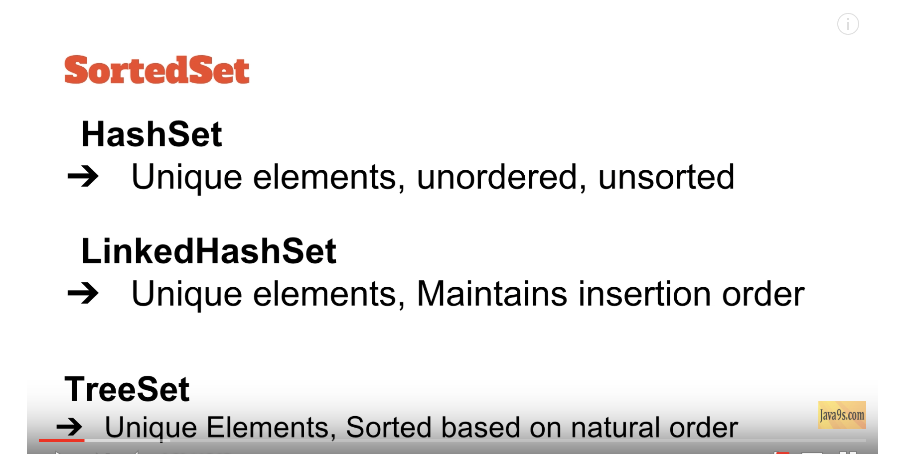

Notes about HashSet

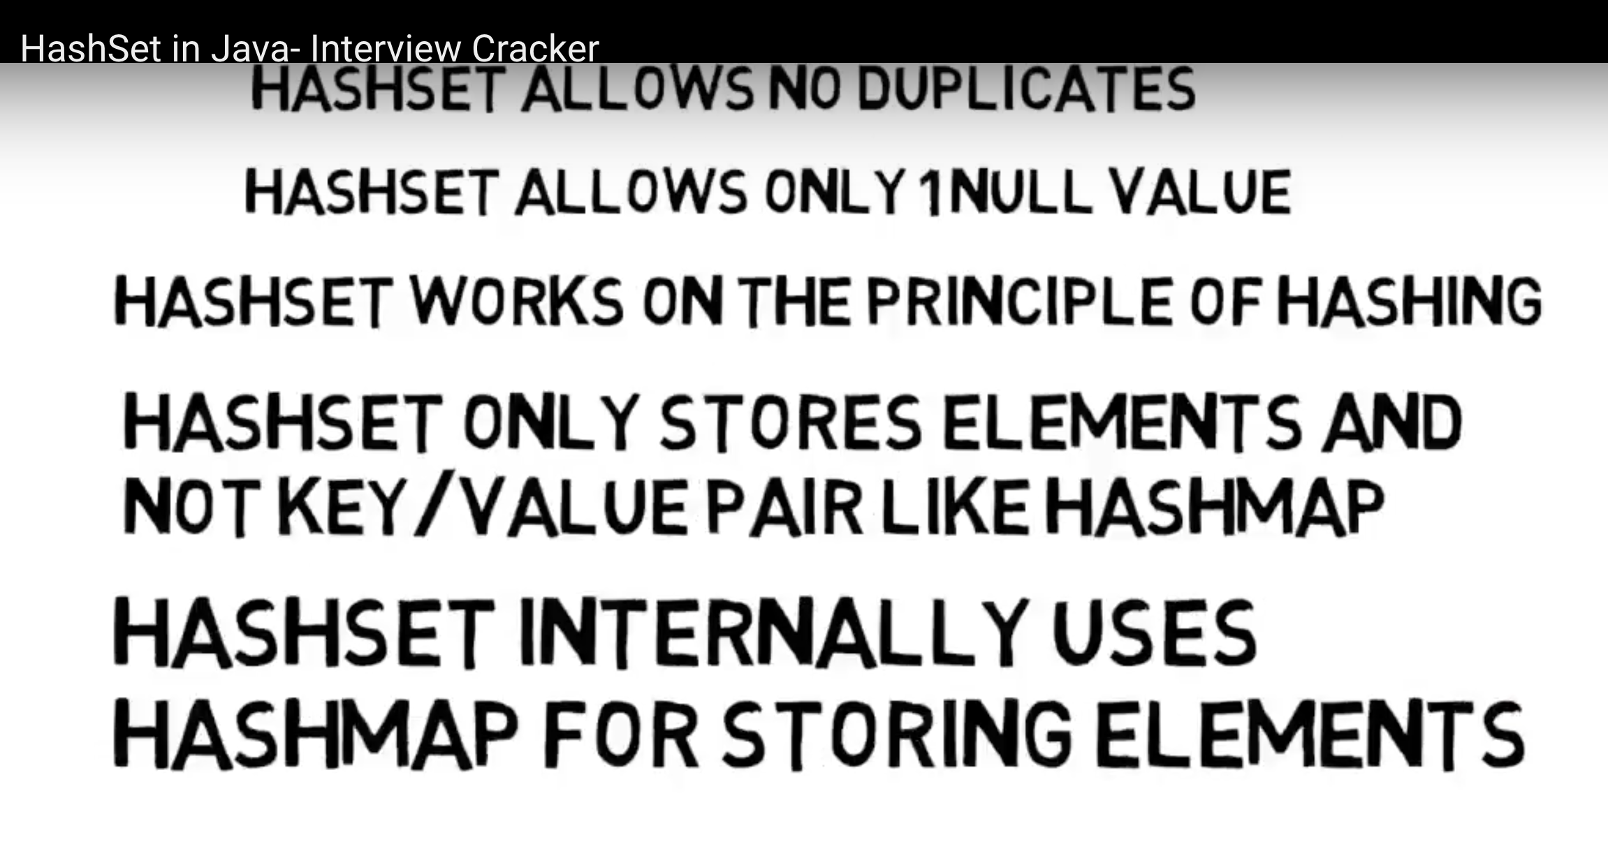

In the case of remove:

It exactly tells you whether any object was removed from your collection or it wasn't.

In the case of add:

It's helpful in collections like Set, because it returns true if a new element added to the set, and it returns false, if the object is already in the collection.

From HashSet:

public boolean add(E e) {

return (this.map.put(e, PRESENT) == null);

}

HashTable Vs HashSet

<https://www.youtube.com/watch?v=UYqOUPNUfLI>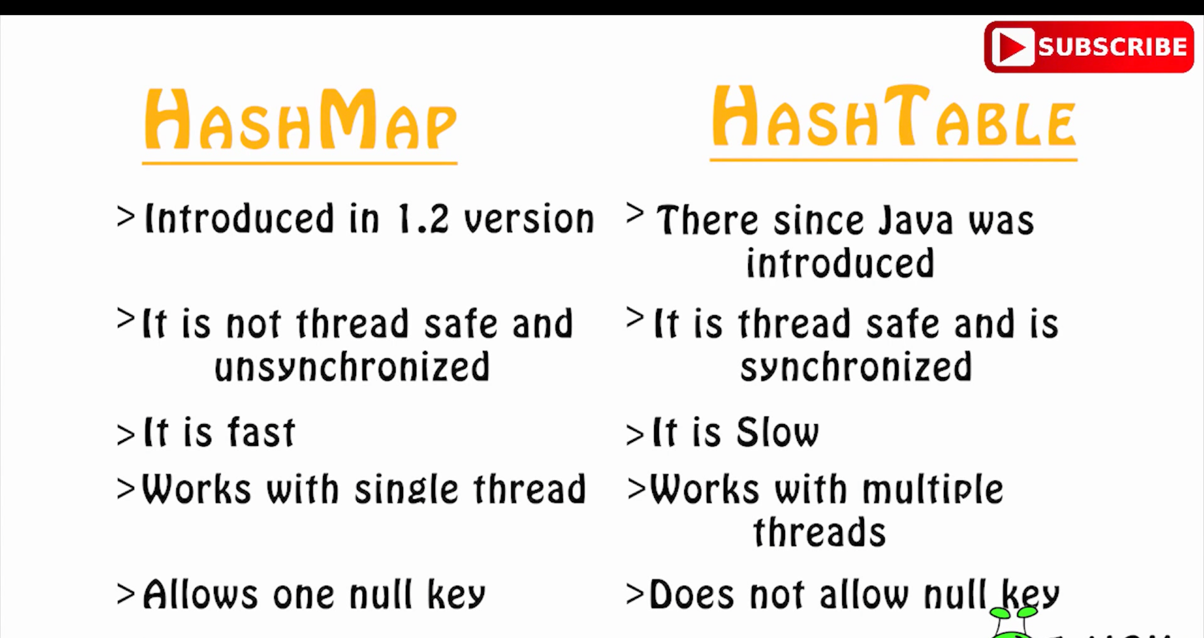

**INSERTION and DELETION OPERATIONs in LinkedList and ArrayList**

Why and how is the linkedList good for fast insertion and deletion while the arraylist good for fast iteration and retrieval?

Also, why and how is the LinkedHashMap fast for iteration and slow for insertion and deletion ?

The fact why LinkedList is good for fast insertion/deletion and ArrayList is good for fast iteration/retrieval lies in the way they are implemented.

**ArrayList**

The ArrayList saves elements in a normal array. This means it can access elements by array[index_number]. When deleting elements, the ArrayList moves all elements after the current index, one index to the left. With many elements this takes some time. The same goes for inserting elements at a specific index: all elements >= than the index get moved one to the right.

To handle increasing number of elements, the backing array sometimes needs to grow. When this is necessary all elements in the current array get moved to a bigger array. This happens, if necessary, when you add elements. This takes some extra time.

**LinkedList**

A LinkedList on the other hand saves its element in an entirely different way. Each element in an LinkedList, keeps a reference to the element before and after it in the List. So you get sort of a chain. Like:

Element 1 <--> Element 2 <--> Element 3 <--> Element 4

Now, when you remove an element, say Element 2, Element 1 will refer to Element 3 as its next element, and Element 3 will refer to Element 1 as its element before. This results in:

Element 1 <--> Element 3 <--> Element 4

So when deleting an element, this results in only two operations:

Change Element 1's next reference to Element 3

Change Element 3's next reference to Element 1

This makes deletion very fast in LinkedList. You don't have to move all elements beyond it like with an ArrayList. The same goes for inserting elements at a specific index:

Let the element before refer to the inserted element as its next element

Let the element after refer to the inserted element as its previous element

Faster again. However, when traversing and retrieving specific elements, you have to go through the elements one by one. So when you want to get element 4, the following happens:

Get first element's next element

Get second element's next element

Get third element's next element and return it

(This is just an illustration. In reality the List will traverse backwards when (size of list / 2) <= index. Starting with the last element.)

In this case ArrayList would be faster, as it can access the element directly in the array.

**Comparable VS Comparator Interface:**

<https://www.youtube.com/watch?v=oT973Y-IiMA>

**https://www.youtube.com/watch?v=iTC43mLZG38**

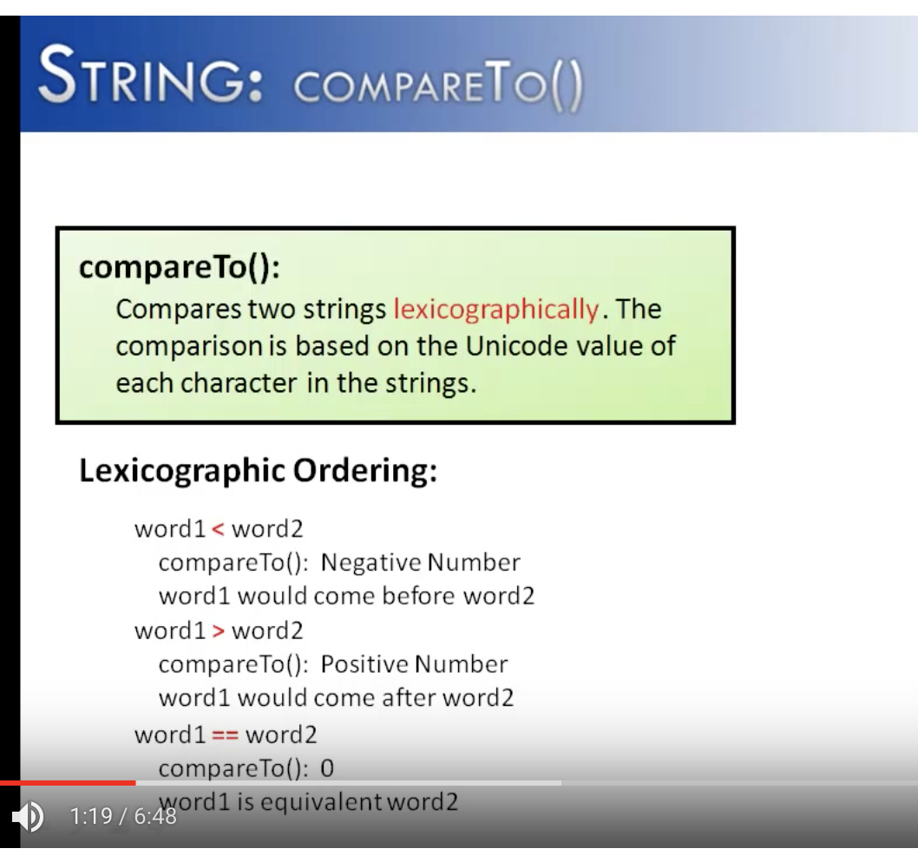

COMPARABLE – Natural Ordering

compareTo()

<https://www.youtube.com/watch?v=iTC43mLZG38>

COMPARATOR- Custom Compare

compare()

Look at the these methods.

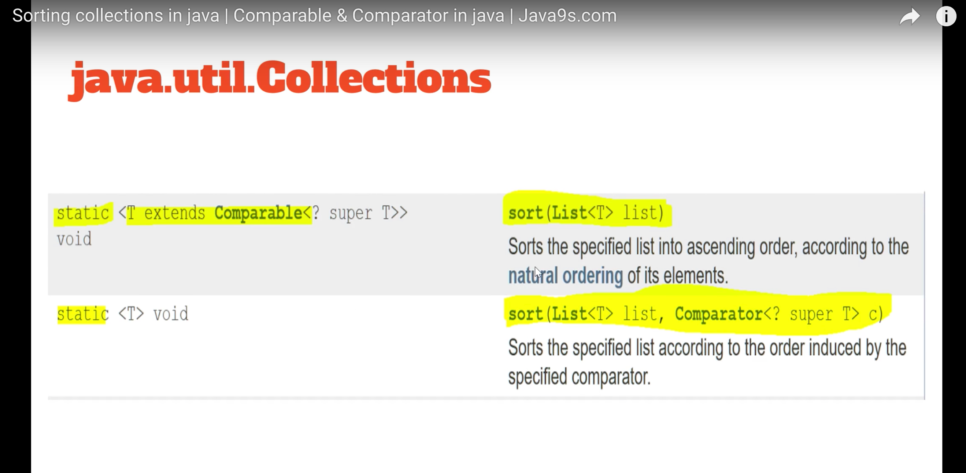

**SORTING COLLECTIONS IN JAVA:**

https://www.youtube.com/watch?v=oT973Y-IiMA

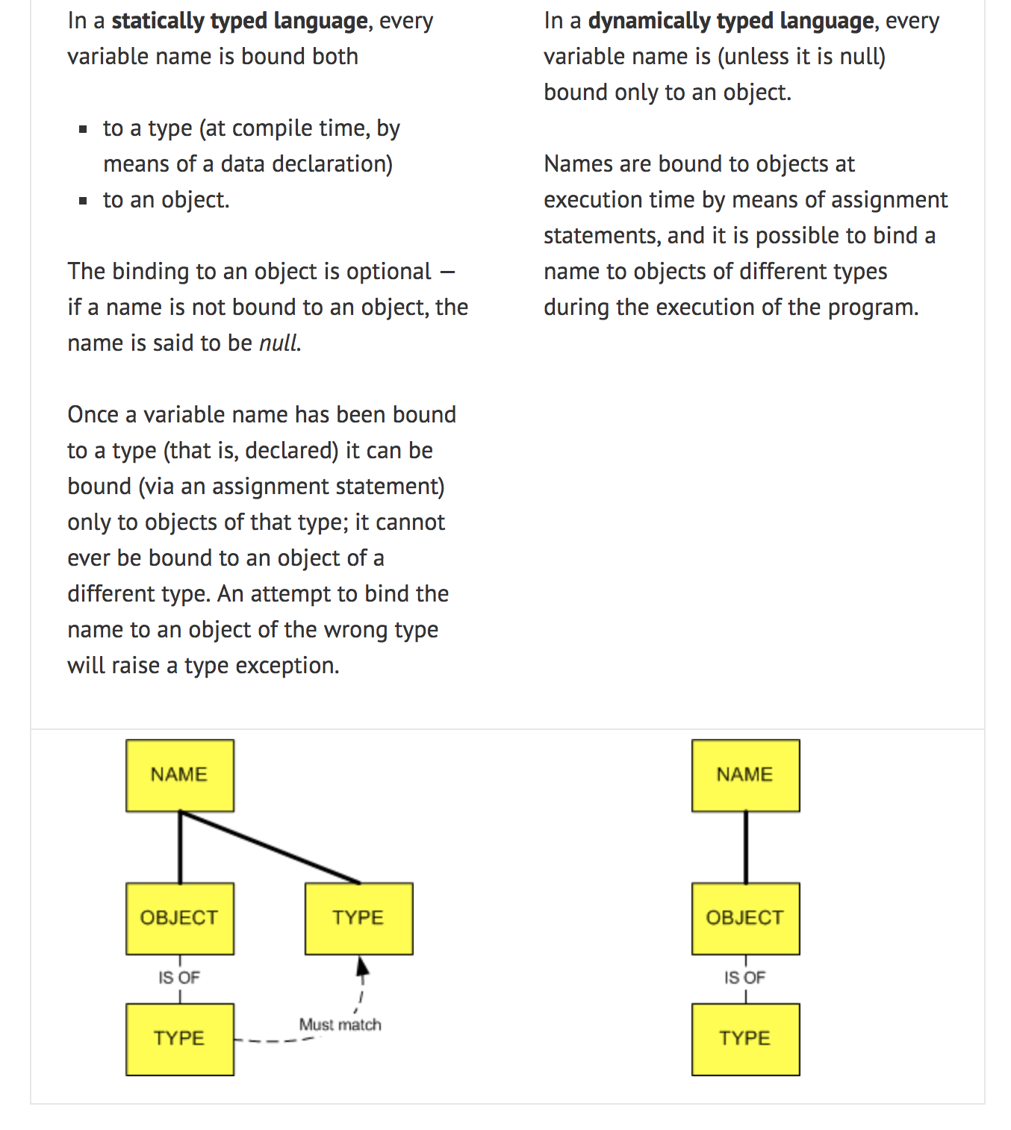

Here is an example.

In a statically-typed language, the following sequence of statements (which binds an integer object, then a string object, to the name **employeeName**) is illegal. If **employeeName** had been declared to be an **int**, then the second statement would be illegal; if it had been declared to be a **String**, then the first statement would be illegal. But in a dynamically-typed language this sequence of statements is perfectly fine.

|  |
| --- |
| employeeName = 9  employeeName = "Steve Ferg" |

In a **weakly typed language**, variables can be implicitly coerced to *unrelated* types, whereas in a strongly typed language they cannot, and an explicit conversion is required. (Note that I said *unrelated* types. Most languages will allow implicit coercions between related types — for example, the addition of an integer and a float. By *unrelated* types I mean things like numbers and strings.) In a typical weakly typed language, the number 9 and the string “9” are interchangeable, and the following sequence of statements is legal.

|  |
| --- |
| a = 9  b = "9"  c = concatenate(a, b) // produces "99"  d = add(a, b) // produces 18 |

In a **strongly typed language**, on the other hand, the last two statements would raise type exceptions. To avoid these exceptions, some kind of explicit type conversion would be necessary, like this.

|  |
| --- |
| a = 9  b = "9"  c = concatenate( str(a), b)  d = add(a, int(b) ) |

**Statically typed:** Java

**Dynamically typed:** Python

**Strongly typed:** Java, Python

**Weakly typed:** Perl

**THREADS:**

<https://www.youtube.com/watch?v=IYBrtzOvfqo>

**Slide No-15**

**Why is thread a lightweight process?**

**process:**

* process id
* environment
* folder
* registers
* stack
* heap
* file descriptor
* shared libraries
* instruments of interprocess communications (pipes, semaphores, queues, shared memory, etc.)
* specific OS sources

**Thread:**

* stack
* registers
* attributes (for sheduler, like priority, policy, etc.)
* specific thread data
* specific OS sources

**Lightweight**

The claim that threads are "lightweight" is - depending on the platform - not necessarily reliable.

An operating system thread has to support the execution of native code, e.g. written in C. So it has to provide a decent-sized stack, usually measured in megabytes. So if you started 1000 threads (perhaps in an attempt to support 1000 simultaneous connections to your server) you would have a memory requirement of 1 GB in your process before you even start to do any real work.

This is a real problem in highly scalable servers, so they don't use threads as if they were lightweight at all. They treat them as heavyweight resources. They might instead create a limited number of threads in a pool, and let them take work items from a queue.

As this means that the threads are long-lived and small in number, it might be better to use processes instead. That way you get address space isolation and there isn't really an issue with running out of resources.

In summary: be wary of "marketing" claims made on behalf of threads. Parallel processing is great (increasingly it's going to be essential), but threads are only one way of achieving it.

**Simple Queuing System**

Process creation is "expensive", because it has to set up a complete new virtual memory space for the process with it's own address space. "expensive" means takes a lot of CPU time.

Threads don't need to do this, just change a few pointers around, so it's much "cheaper" than creating a process. The reason threads don't need this is because they run in the address space, and virtual memory of the parent process.

Every process must have at least one thread. So if you think about it, creating a process means creating the process AND creating a thread. Obviously, creating only a thread will take less time and work by the computer.

In addition, threads are "lightweight" because threads can interact without the need of inter-process communication. Switching between threads is "cheaper" than switching between processes (again, just moving some pointers around). And inter-process communication requires more expensive communication than threads.

A **process** includes code (text section) and the current activity (program counter and the content of registers)

**Execution Context:**

The state of a process is called an execution context

The state of a process includes both its memory and the location of the current instruction being executed.

**Context Switch:**

A **context switch** is the process of storing and restoring the [state](https://en.wikipedia.org/wiki/State_(computer_science)) (more specifically, the execution [context](https://en.wikipedia.org/wiki/Context_(computing))) of a [process](https://en.wikipedia.org/wiki/Process_(computing)) or [thread](https://en.wikipedia.org/wiki/Thread_(computing)) so that execution can be resumed from the same point at a later time. This enables multiple processes to share a single [CPU](https://en.wikipedia.org/wiki/Central_processing_unit) and is an essential feature of a [multitasking operating system](https://en.wikipedia.org/wiki/Multitasking_operating_system).

**find an example of what multitasking and multithreading is:**

**Concurrency:**

The term concurrency denotes a program in which **two or more execution contexts can be active simultaneously**

**Single-threaded-**Programs with single execution contexts

**Multi-threaded-**Programs with multiple execution contexts

In Multi-threaded programs,

part of the program state is shared among the threads,

while part of the state is unique to each thread

**Monitor**

A thread will grab onto a monitor.

This will prevent all threads from grabbing that same momnitor and will force them to wait until the monitor is released by the first thread.

This is what a synchronizedblock does.

**Where do these monitors come from in the first place?** Every object by design has a monitor associated with it.

Ex:

Object foo = new Object();

synchronized (foo) {

System.out.println("Hello world.");

}

Here object **foo** has a monitor associated with it.

The current thread will first grab the monitor associated with the object stored in variable **foo**and hold it while it prints "Hello world", then releases it.

**What would happen in case of synchronized methods. We don't have an object associated with it, so there would be no monitor used**

A synchronized method is equivalent to synchronized(this) {}, while a static synchronized method uses the class object as its monitor.

<http://tutorials.jenkov.com/java-concurrency/synchronized.html>

**Synchronized blocks:**

When using synchronized with blocks, you specify an object to lock on. In that case, the monitor of that object is used for locking I.e the thread will grab on to the monitor of that object and that monitor is locked by the thread.

**Synchronized methods:**

When using synchronized with methods, you don't specify an object to lock on, and instead this object is implied. Again, the monitor of this is used for locking.

Synchronized methods/blocks do not have their own monitors, but instead they use the monitors of specific objects.

Again: A synchronized instance method in Java is synchronized on the instance (object) owning the method.

Only one thread can execute inside a synchronized instance method. If more than one instance exist, then one thread at a time can execute inside a synchronized instance method per instance. One thread per instance.

 A synchronized instance method uses the object it belongs to as monitor object.

public class MyClass {

public **synchronized** void log1(String msg1, String msg2){

log.writeln(msg1);

log.writeln(msg2);

}

public void log2(String msg1, String msg2){

**synchronized(this){**

log.writeln(msg1);

log.writeln(msg2);

**}**

}

}

Thus only a single thread can execute inside either of the two synchronized blocks in this example.

Had the second synchronized block been synchronized on a different object than this, then one thread at a time had been able to execute inside each method.

**Synchronized Static Methods:**

Synchronized static methods are synchronized on the class object of the class the synchronized static method belongs to. Since only one class object exists in the Java VM per class, only one thread can execute inside a static synchronized method in the same class.

public class MyClass {

public static synchronized void log1(String msg1, String msg2){

log.writeln(msg1);

log.writeln(msg2);

}

public static void log2(String msg1, String msg2){

synchronized(MyClass.class){

log.writeln(msg1);

log.writeln(msg2);

}

}

}

Only one thread can execute inside any of these two methods at the same time.

Had the second synchronized block been synchronized on a different object than MyClass.class, then one thread could execute inside each method at the same time

<http://tutorials.jenkov.com/java-concurrency/synchronized.html>